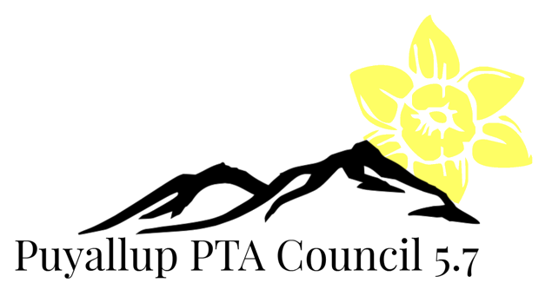

The Puyallup PTA Council Mission Statement is…
To support, mentor, educate and empower local PTAs. We will accomplish this by:
- Engage the local PTAs.
- Fostering membership growth.
- Motivate and encourage local PTA’s to participation.
- Promote leadership development at the local PTA and council levels.

Puyallup PTA Council Goals 2018/2019

- Engage the local PTAs
  - Achieve participation by every local PTA at a minimum of one Puyallup PTA Council sponsored event, meeting or training.
  - Provide mentoring to all PTAs and potently new PTAs in Puyallup.

- Fostering Membership Growth
  - Provide all local PTAs with membership education.
  - Increase council membership by 3%.

- Motivate and encourage local PTA’s participation.
  - Increasing the representation of local PTA participation at WSPTA Legislative Assembly, WSPTA Focus Day and WSPTA issue submittal from last year totals.
  - Increase representation on the PPC FACE team to 50% of local PTAs.
  - Encourage local PTAs all participate or host at least one Family and Community Engagement (F.A.C.E) event.

- Promote leadership development at the local PTA and council levels.
  - Increase the number of filled committee chair positions by instituting a board “Sustainability Initiative”.

PPC 2018/19

